**3: HISTOGRAM EQUALIZATION OF IMAGES**

clc;

closeall;

clearall;

A=imread('C:\Users\Public\Pictures\SamplePictures\flower1.jpg');

a=rgb2gray(A);

b=double(a);

maxm=max(max(b));

minm=min(min(b));

[r,c]=size(b);

Cn=r*c;

h=zeros(1,300);

z=zeros(1,300);

for m=1:1:r

for n=1:1:c

if(b(m,n)==0)

b(m,n)= 1;

end

end

end

for m=1:r

for n =1:c

t = b(m,n);

h(t) = h(t) + 1;

end

end

PDF = (h/Cn);

CDF(1) = PDF(1);

for x = 2:maxm

CDF(x) = PDF(x)+ CDF(x-1);

end

new = round(CDF * maxm);

new = new + 1;

for p = 1:r

for q =1:c

temp = b(p,q);

b1(p,q) = new(temp);

t = b1(p,q);

z(t)= z(t) +1;

end

end

b1 = b1-1;

subplot(3,2,1);

imshow(uint8(b));

title('Orignal Image');

subplot(3,2,2);

bar(h);

title('Histogram of original image');

subplot(3,2,3);

imshow(uint8(b1));

title('output image');

subplot(3,2,4);

bar(z);

title('Histogram equalization of the image');

subplot(3,2,5);

J = histeq(a);

imshow(J)

title('Output Image using function');

subplot(3,2,6)

imhist(J,64)

title('Histogram equalization image using function');

**OUTPUT :**

**Bright image**

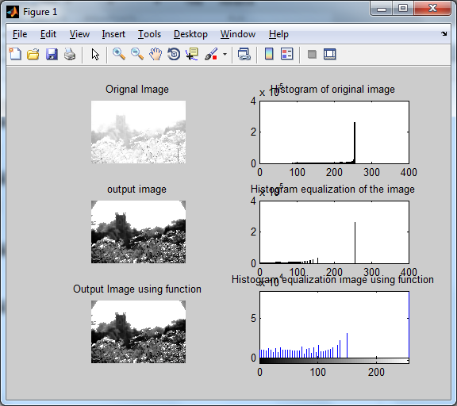

Gray image :

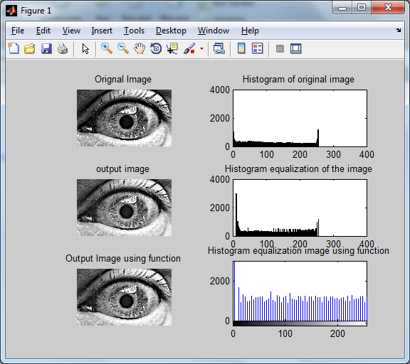

**Dark image :**

